Biographies
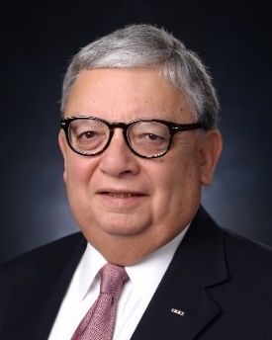 | The Honorable Albert C. Zapanta  President and CEO USMCOC  Albert C. Zapanta is President and CEO of the United States—Mexico Chamber of Commerce. He is responsible for operations in 19 regional offices in the United States and Mexico.  In the private sector, Mr. Zapanta was an executive with ARCO for 18 years. In public service, Mr. Zapanta has held a number of  presidential appointments and was a member of the Department of State′s Advisory Committee on International Trade, Technology and Development, and private sector delegate to the U.S.-Mexico Partnership for Prosperity.  General Zapanta's military record includes the award of the Silver Star, five Bronze Stars for Valor, the Purple Heart and thirty other awards during the Vietnam War. Mr. Zapanta was appointed by the Governor of the Commonwealth of Virginia to the rank of Major General.  He currently serves on the boards of various non-profit organizations across the country. In June 2018, he was elected and reelected in 2021 to serve on the Irving City Council, State of Texas. Mr. Zapanta was born in Los Angeles, California. He is a graduate of Harvard School of Business.
Luncheon. Keynote Speaker

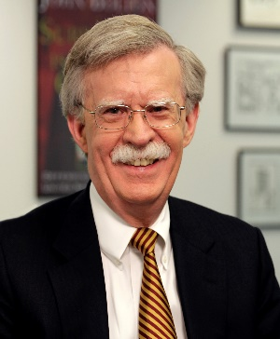 | Ambassador John R. Bolton  John R. Bolton is an American diplomat, attorney, and author who served as Assistant to the President for National Security Affairs from April 2018 to September 2019. He was the U.S. Permanent Representative to the United Nations from 2005 to 2006 and held multiple roles in the State Department, including Under Secretary of State for Arms Control and International Security (2001–2005) and Assistant Secretary for International Organization Affairs at the Department of State, 1989-1993.  Ambassador Bolton has spent many years of his career in public service. Previous positions he has held include Assistant Attorney General, Department of Justice (1985-1989); Assistant Administrator for Program and Policy Coordination, U.S. Agency for International Development, (1982-1983) and General Counsel, U.S. Agency for International Development (1981-1982).  Bolton has been a vocal advocate for strong national defense policies and has written extensively on U.S. foreign policy. A graduate of Yale College and Yale Law School, he currently resides in Maryland with his wife, Gretchen.
Guest Speakers
Panel I. Border Issues, Security and Immigration

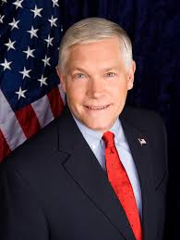 | Hon. Pete Sessions  U.S. Congressman (TX-17th)  Congressman Pete Sessions is a dedicated public servant representing Texas in the 17th Congress. A native of Waco, Texas. Elected to Congress in 1996, Pete has played a crucial role in Republican leadership, serving as Chairman of the National Republican Congressional Committee and the House Committee on Rules. He is currently a senior House Financial Services Committee member and chairman of the Subcommittee on Government Operations and the Federal Workforce. Known for passing significant legislation, Pete sponsored the Border Tunnel Task Force Act and the Family Opportunity Act, which provides healthcare for families with medically stressed children. An Eagle Scout and active community leader, Pete has served on various boards, including Southwestern University's Board of Trustees. He lives in Waco, Texas, with his wife Karen; they have five sons.
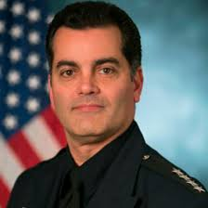 | Robert Perez  Founder and CEO, P4 Partners, and former Deputy Commissioner of US Customs and Border Protection  Robert E. Perez is the Founder and CEO of P4 Partners and a former Deputy Commissioner of U.S. Customs and Border Protection (CBP), where he served as the agency’s senior career official. In this role, he led over 60,000 employees and managed a $15 billion budget, overseeing CBP’s national security operations across U.S. borders and in 50 countries worldwide.  With a career spanning more than 25 years in federal law enforcement, Mr. Perez also held key leadership positions as Executive Assistant Commissioner for Operations Support and Director of Field Operations in both New York and Detroit. He was the founding Director of the Customs–Trade Partnership Against Terrorism (CTPAT), advancing CBP’s industry partnership and supply chain security efforts. His work has earned him honors such as the “Distinguished Executive” award from the President of the United States and the “True American Hero” Lifetime Achievement Award.  Mr. Perez holds a degree in Economics from Rutgers University, is fluent in Spanish, and is a graduate of Harvard Kennedy School’s Senior Executive Fellows program. He also serves on several advisory boards and is the Co-Chairman of The CBP Foundation, which supports CBP employees and their families.
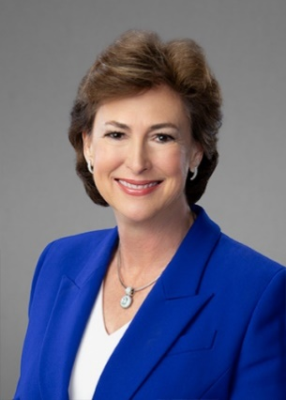 | Kim Ogg  Harris County District Attorney  Kim Ogg, Harris County District Attorney, is a native Houstonian and has been a lawyer for 35 years. In 2020, DA Ogg was re-elected to a second term by a margin of more than 120,000 votes. Under her leadership, the Harris County District Attorney's Office is dedicated to community safety through evidence-based prosecution and equal justice for all.  During her first term, DA Ogg successfully advanced major drug policy reform, police accountability through prosecution of police corruption and shootings, diversified the leadership of the District Attorney's Office, and effected protection for crime victims through legislative reform.  She served as a Senior Policy Advisor to Harris County Commissioner Tom Ramsey, and Ms. Ogg has now re-entered the private legal sector.
Guest Speakers
Panel II. Tariffs and their impact on Supply Chain, Manufacturing, Logistics and Agriculture: the USMCA Review 2025-2026

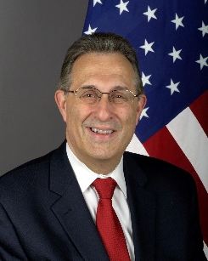 | Amb. Earl Anthony Wayne  Hurst Senior Professorial Lecturer and Distinguished Diplomat in Residence, American University, and  Former Ambassador to Mexico  Ambassador Earl Anthony Wayne is currently teaching as a  Distinguished Diplomat in Residence at American University's  School of International Service. He is a Public Policy Fellow at the  Woodrow Wilson Center for International Scholars and Co-Chair  of the Advisory Board of its Mexico Institute. Wayne is a former  Assistant Secretary of State for Economic and Business Affairs, a  former U.S. Ambassador to Mexico and to Argentina and a former  Deputy Ambassador in Afghanistan. He left the U.S. diplomatic  corps with the rank of Career Ambassador. Wayne is also a Senior  Non-Resident Adviser at the Center for Strategic and International  Studies at the Atlantic Council. He serves on the Board of  the American Academy of Diplomacy. Wayne speaks, writes and  consults on a range of international and management topics.
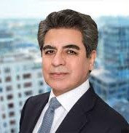 | Javier Velez  CEO, El Dorado Foods  Former President and CEO of Mission Foods  Javier Velez is CEO of El Dorado Foods™, a multi-category platform focused on acquiring and developing innovative Latin-inspired food and beverage brands. He also serves as an Industry Advisor to Berkshire Partners, a role he has held since 2020, offering strategic insight across investment activities and portfolio development.  Previously, Javier was CEO of Mission Foods, the largest subsidiary of Gruma S.A.B. de C.V., and the global leader in fresh tortillas and Mexican food products. His career also includes executive leadership roles at Gruma and as CEO of Nacional Monte de Piedad, Mexico’s oldest financial institution.  Javier serves on the Executive Board of SMU Dedman College and has been a board member of both Gruma and Banorte. He brings decades of leadership in the food, finance, and consumer goods sectors, with deep expertise in brand development and operational strategy.

Guest Speakers
Panel III. 2025 Mexico’s Judicial Election Observers Mission

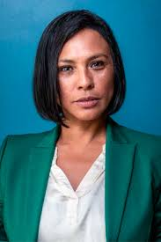 |  | Norma Irene de la Cruz  Electoral Council woman, National Electoral Institute of Mexico (Instituto Nacional Electoral-INE)  Norma Irene de la Cruz Magaña is an Electoral Councilor at Mexico’s National Electoral Institute (INE), appointed in 2020 by the Chamber of Deputies. She holds a degree in Journalism and Mass Communication from UNAM and a Master’s in Peacekeeping Management from the University of Turin.  With nearly two decades of international experience, she has worked in electoral operations and peacekeeping missions across Kosovo, Liberia, Sierra Leone, Nepal, Sudan, and more. She has led and advised EU election observation missions and consulted for organizations including IFES, UNDP, the UN, and the European Commission.  At INE, she chairs the Commission on Gender Equality and Non-Discrimination and serves on several key electoral committees, including those for Electoral Organization and the vote of Mexicans abroad.
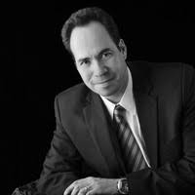 |  | Antonio Cuéllar Steffan Founding Partner, Cuéllar Salas y Cuéllar Steffan Law Firm  Antonio Cuéllar Steffan is a seasoned attorney with over 20 years of experience in constitutional, administrative, Amparo, and commercial law. A graduate of UNAM’s Law School, he holds a Master’s in Foreign Trade and is currently a doctoral candidate at UNAM. He also completed specializations in litigation and international trade at institutions including the Universidad Panamericana, ITAM, and the University of San Diego, Paris campus.  Mr. Cuéllar has served as legal counsel for Petróleos Mexicanos (PEMEX) and Grupo Televisa, and held a key advisory role on North American Free Trade at Mexico’s Secretariat of Commerce. He founded the Mexican Association for International Law Students and represented Mexico in the U.S.-Mexico Chamber of Commerce’s “Buen Vecino” program.  An experienced legal educator, he has taught constitutional law courses at UNAM, Universidad Anáhuac del Sur, and Universidad Panamericana. Fluent in English and French, Mr. Cuéllar is a member of the Mexican Bar of Attorneys and has extensive experience in international legal negotiations.

